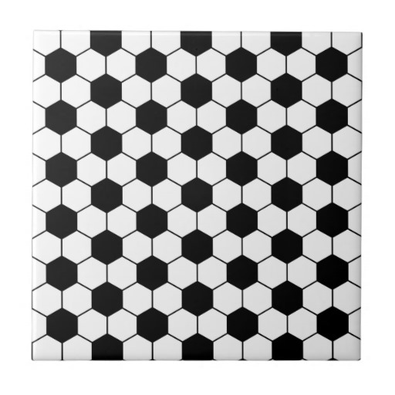SECTION

**VIP 8 2015**

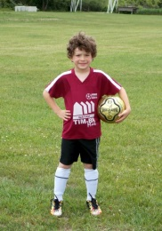

**TRISTAN’S**

**8th**

**BIRTHDAY!**

**TRISTAN’S**

**8th**

**BIRTHDAY!**

**TRISTAN’S**

**8th**

**BIRTHDAY!**

SECTION

**VIP 8 2015**



**TRISTAN’S**

**8th**

**BIRTHDAY!**

**TRISTAN’S**

**8th**

**BIRTHDAY!**

**TRISTAN’S**

**8th**

**BIRTHDAY!**

SECTION

**VIP 8 2015**



**TRISTAN’S**

**8th**

**BIRTHDAY!**

**TRISTAN’S**

**8th**

**BIRTHDAY!**

**TRISTAN’S**

**8th**

**BIRTHDAY!**